**UML DIAGRAM FOR ONLINE VOTING SYSTEM**

**Aim:**

To draw UML diagram for Online Voting System using umbrello tool.

**USE CASE DIAGRAM**

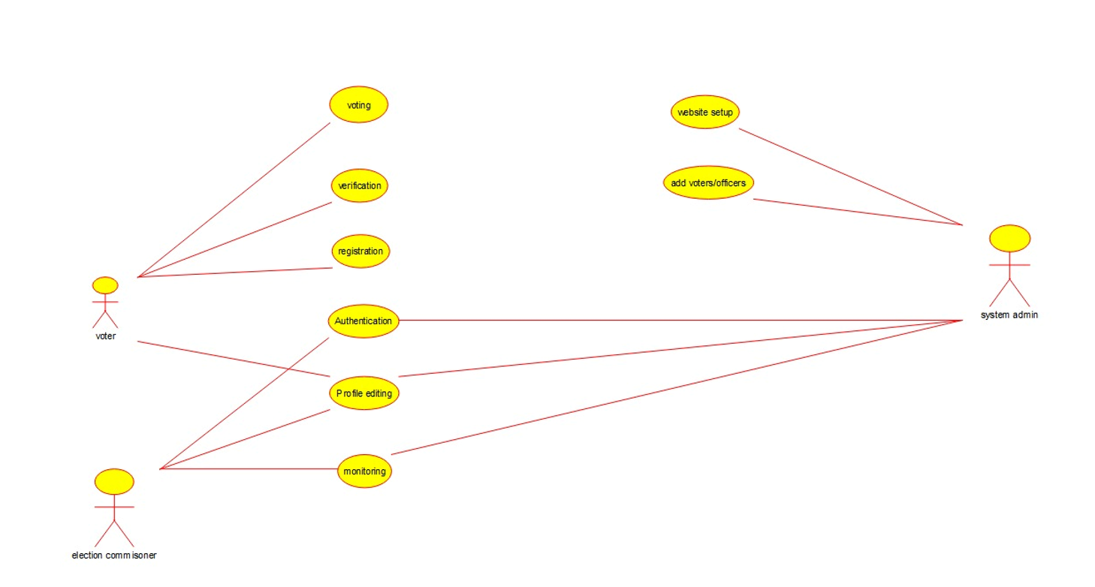

**CLASS DIAGRAM**

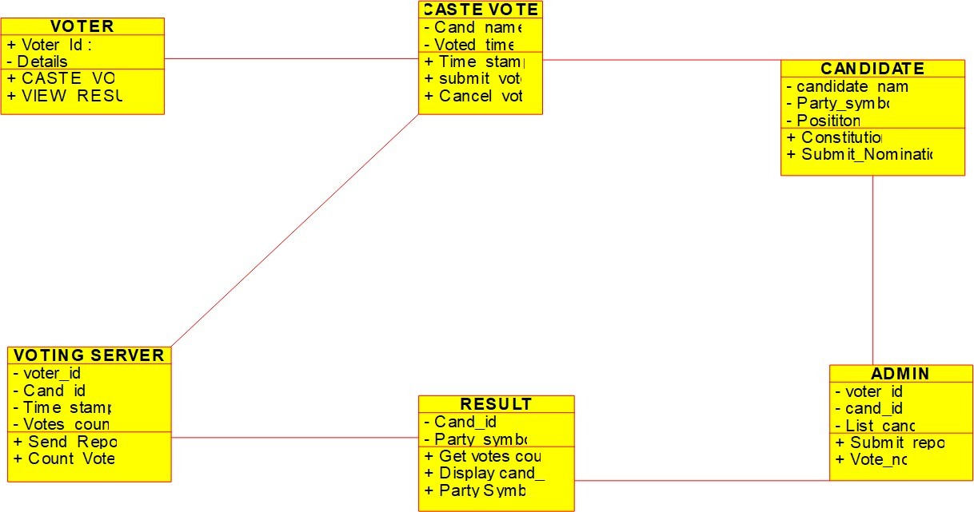

**SEQUENCE DIAGRAM**

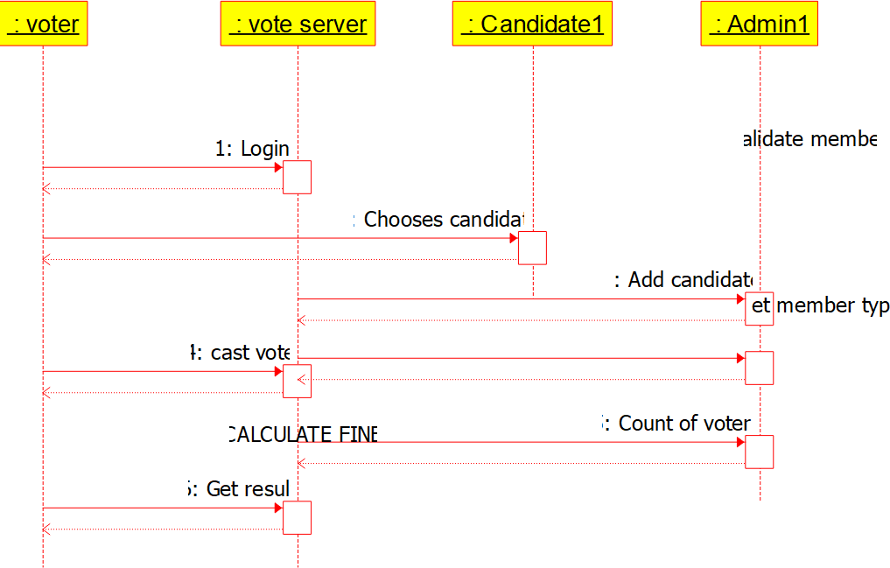

**ACTIVITY DIAGRAM**

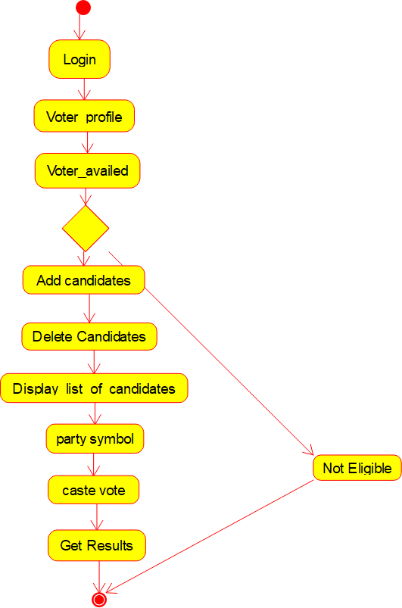

**RESULT**

Hence these diagrams for Online Voting System are drawn and verified successfully.